Project Closure Report
For <Schedule It Phase II>
By<Brijesh Pant>

Revised By | Revised On | Version | Comment

Table of Contents
1 Achievements 4
2 Problems Faced 4
3 Risk Summary 4
4 Recommendation for future projects 4
5 Recommendation for process improvements 4
6 Review of metrics data and variations analyzed? 4
7 Whether Project Repository is archived? 4
8 Whether access has been removed for the team? 4
9 Final Estimation 4
10 Bid Hours/Portal Information 4
11 UAT Closure 4
12 Source Code confirmation from client end? 5
13 Live URL 5
14 What is final project completeion rating status on Portal? 5
15 What is the future scope of the project in smartdata? 5
16 Performance of the Team members 5
17 Project learnings shared on VP or knowledge forum?. 5
18 Approval of sales for closure 5

Achievements*
Integrated Google Map API(Google Map Api)
Google Calendar Sync(Google Calendar Api)

Problems Faced*
While doing Implementation of Routing based on business and google calendar Sync

Risk Summary*
N/A

Recommendation for future projects*
N/A

Recommendation for process improvements*
Design should be ready before development it will help the project to be complete on time.

Review of metrics data and variations analyzed?
Yes

Whether Project Repository is archived? *
[Get source code and project repository archived by IS Team.]
Not Required since project may move to next phase.

Whether access has been removed for the team? *
VP – No
ACE/ Basecamp – No
Datacenter (Project Repository) – No

Final Estimation*
1294.5

Bid Hours/ Portal Information*
1294.5

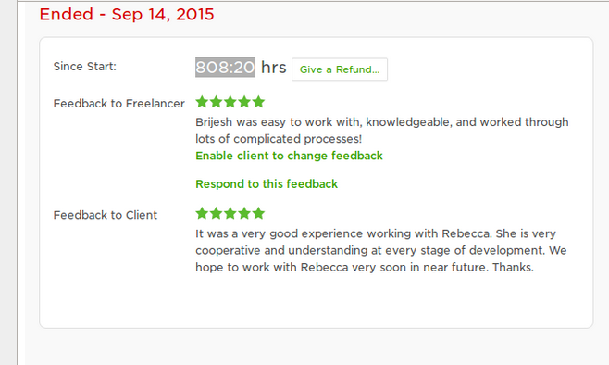

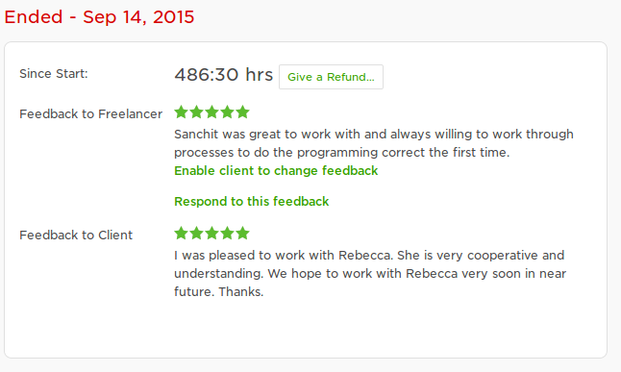

UAT Closure*
[Link final acceptance/closure email of project provided by client.]

Source code confirmation from client end?*
[Link final Source code confirmation email of project by client.]

https://scheduleit.org/

We worked on the GIT Repository and all the code has been updated on the client
GIT repository

Live URL*
https://scheduleit.org/

What is final project completion rating status on portal? *
5 star

What is the future scope of project in smartData?*
[Will client continue with some new project or phase 2? Or is there any module/function which could be enhanced further?]
Client will provide task as per the requirement in upcoming weeks or months

Performance of the Team members*
Resource Name | Designation | Worked in Project <From Date – To Date> | Overall Rating: | Training recommendations:
Brijesh Pant | PI | 23March-16August | 5/5
Sanchit Negi | Developer | 7April-10 July | 5/5

Project learnings shared on VP or Knowledge Portal?*

Done[http://forums.smartdatainc.com/viewtopic.php?f=4&t=2693&sid=2cefa4b18c65ba7ba70fbfb7fb593593]

Approval of sales for closure?*
[Link final approval email by sales for project closure.]

